1. EU LOGO

* LOGO SIZE (L X H) = **3x** X 2**x (13.5 mm x 9 mm, minimum sizes)**
* Size the logo match in to the webpage using length & height ratio

LK-BIO-149

CU853200

Non-EU Agriculture – Sri Lanka

1. USDA LOGO

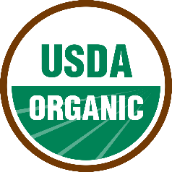

1. Control Union Logo



1. FDA LOGO

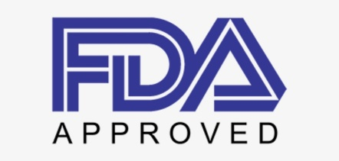

FDA REG NO: 13534907644

1. FOOD SAFTEY

**ISO22000:2018**

**HACCP**

**GMP**

**CERTIFIED COMPANY**

1. EDB Reg

**Reg No: 229896**

1. CDA Logo



REGISTERED MANUFACTURER & EXPORTER